Summer Reading Programs 2017

Mitchell Public Library & South Branch Public Library both have summer reading programs which encourage students to READ and earn prizes and certificates for reading a set number of books and or pages. They will have guest speakers and since each program differs please look at their events calendar below:
http://www.countylibrary.org/summer.htm
Calendar of events:
http://www.countylibrary.org/summer/mitchell_juv17.pdf

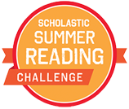

Scholastic Summer Challenge allows students to earn virtual prizes for reading minutes May 9th- September 9th. Students may create an account and tally their minutes for Buckalew at the Scholastic Summer Reading Link:
http://www.scholastic.com/ups/campaigns/src-2017/

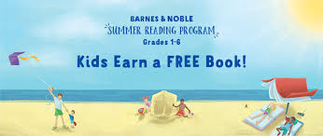

Barnes & Noble Summer Reading Program

Read and fill out a Reading journal and earn a free book!
Step 1. Fill out the Reading Journal.
Step 2. Bring the completed Reading Journal to your local B&N store. Find a Store.
Step 3. Choose a FREE BOOK from our selection on the Reading Journal list at the store... Enjoy reading!

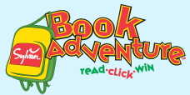 K- 1st grade

Book Adventure – This is a free program offered by Sylvan Learning. Kids in grades K–8 can search for books, read them offline, come back to quiz on what they've read, and earn prizes for their reading success. Prizes include chocolate bars, temporary tattoos, Highlights magazine and more.

Hats off to Reading-
Our Annual Hats off to Reading will be held – June 9th at the Cynthia Woods Mitchell Pavilion. 5:30pm

Happy Reading this summer!! Don’t forget to read at least 30 minutes / day this summer.

Mrs. Campo - Librarian

